**FI Implementation: Fallen Angels**

Group 3

Michael Demian | Yiran Xia | Aravind Ganesan | Rajat Gupta | Sanchi Bhavesh Shah

Introduction:

Approximately 95% of the bond credit rating industry is controlled by three firms, Moody’s, Standard & Poor, and Fitch. Many fixed income funds will only carry investment-grade bonds in their portfolios and as the credit rating industry is so highly concentrated, a downgrade could heavily affect the bond’s price. Investment grade bonds for Fitch and S&P carry a rating of BBB- or above, while it is Baa3 or above for Moody’s. When the credit worthiness of a bond decreases below this threshold to junk bond status, there is a significant sell off as these fixed income funds can no longer hold these bonds in their portfolios. As a result, there should exist a trading opportunity when such downgrades happen. For basic implementation, any such downgrades has been treated as a trading signal, leading us to short the junk bonds and create a pure short portfolio, as the expectation is that their prices are going to further drop. For extension, realizing the nature of the basic short portfolio, duration hedging is incorporated as well as cost of borrowing to mimic real life tradings.

There was a limitation in data collection as the CUSIP of the bonds that were included in the portfolio had to be manually collected and involved an arduous search to find and verify that the data is present and available for each bond. This process allowed us to only collect a limited amount of bonds for testing and a key improvement to this implementation would be significantly increasing our universe of bonds to be tested.

I.  Specification

1. Universe

* This implementation utilizes a universe of corporate bonds, specifically those that have been downgraded by the S&P from BBB- or above to BB or below.
* For basic implementation, only the downgraded bonds have been included in the short portfolio.
* For extension, in order to perform duration hedging, the on the run 10-year treasuries as of Jan 2010 was used till 2014 and then again the on the run 10-year treasuries as of 2014 was used till 2018 in the portfolio.

1. Date Range

* In-sample: Jan 2010 to Dec 2016. Started with 2010, since as mentioned earlier, it involved significant amount of manual work in gathering the CUSIP data.
* Out-of-sample: Jan 2017 to Dec 2018

1. Data Sources

* The initial list that includes more than 7,000 companies that had been downgraded by S&P within the back-testing period. It was restricted to companies domiciled in the US and to companies which had a rating post the downgrade. The list was further refined to only include downgrades from investment grade to junk bond category and also restricted to long term bond downgrades. We arrived at 188 such downgrades during 2010-2018 but were able to get CUSIPs for only 53 securities. All mentioned data collection were performed using Bloomberg.
* After manually checking bonds availability of these companies and gathering the CUSIP for available bonds, bonds’ price data was also collected from Bloomberg. CUSIP for the bonds indicated in the attachment.

1. Signal Generation

* As the strategy is event-driven in nature and includes many discretionary judgements, generic signal has been used, which is simply the the downgrade from investment-grade to junk bond by the S&P.

1. Portfolio Construction

* Whenever an announcement for a downgrade is made, the trading algorithm generates a trading signal according to which a short position of USD 1 Mn worth of the downgraded bond is entered
* The position will be closed after 5 trading days

1. Execution

* Dirty prices were used for the bonds that were included in the portfolio in order to incorporate accrued interest component as well
* Mid-price were used to account for the possible bid-ask spread costs
* No slippage nor possible limitations of liquidities of these bonds were considered

II.  Implementation

1. PnL Graph

In-sample:

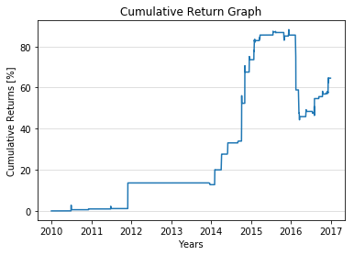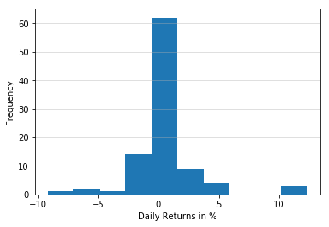

* Cumulative Return: 64.60%
* Annualized Return: 7.38%

**Analysis**

* Both cumulative and annualized return within the 7-year in-sample trading period are reasonable as unlike other high-profile event-driven strategies such as M&A arbitrage that often produce significant returns, Fallen Angel strategy should only produce frequent small returns especially considering the short holding period (5 days) of the implementation.

1. Stats

* Distribution of Daily Returns:
  + Average Daily Return: 0.56%
  + Standard Deviation of Daily Return: 0.67%
  + Skewness: 8.28 & Kurtosis: 195.04
* Sharpe Ratio: 0.83 assuming 2% risk-free interest rate
* Maximum Drawdown of 23.34% occured from 2015-12-14 to 2016-03-21 and had not recovered by the end of the in-sampling period.

**Analysis**

* From the cumulative return series, it is clear that there were frequent periods with no trading activities due to the aforementioned limitation in data availability and hence lack of trading opportunities. As a result, the generated skewness and kurtosis may not be statistically representative.
* Although sharpe ratio is reasonable during the period, it should be kept in mind again, the lack of trading opportunities may have helped smooth out the volatility of the portfolio. Return profiles may change as data availability increases.

1. Difficulties

* Other than the data availability and gathering efficiency, after collecting the CUSIP, it was noticed that the downgrade dates in some cases were on non trading dates and in some cases, trading was even suspended in some of the securities for a few days. As a result, we had to handle it at the data level and at the code level to ensure that this did not impact the backtesting results.

III.  Refinements

1. Implemented Refinement

* Performed Duration hedging - Since our main portfolio is a pure short portfolio, our portfolio, which is purely directional, can also suffer significant loss from general market movement. As a result, in order to hedge such potential loss/gain, duration hedging is performed by constructing a long portfolio with 10 year treasuries such that the duration of the long and short portfolio is the same. This will negate any sort of loss/gain due to general market movements since the gain/loss from short position, will match the loss/gain from the long position.
* Incorporated cost of borrowing, since the bonds shorted needs to be borrowed, such costs may significantly affect the return series of the portfolio.

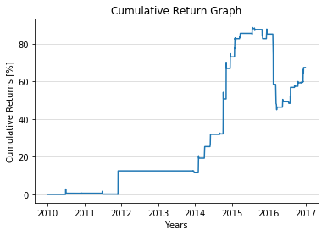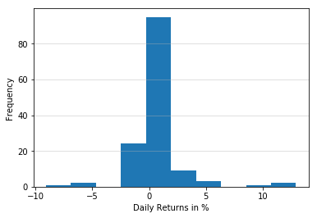

* Cumulative Return: 67.41%
* Distribution of Daily Returns
  + Average Daily Return: 0.40%
  + Standard Deviation of Daily Return: 0.67%
  + Skewness: 8.93 & Kurtosis: 210.88
* Annualized Return: 7.62%
* Maximum Drawdown of 23.21% occured from 2015-07-23 to 2016-03-21 and had not recovered as of the end of in-sampling period.

**Analysis**

* Despite incorporating the cost of borrowing, the return under extension was better in comparison to the basic implementation. This can be attributed to the return from the hedging instrument.

1. Proposals

Suggestions for future research:

* Work with a more extensive dataset to be able to get more accurate and statistically significant implementation results.
* Incorporating returns that could be generated by investing surplus capital at repo rate .
* Perform hedging with eurodollar futures instead of bonds, since they come at a lower cost, to make the portfolio more cost effective
* Run fundamental analysis on companies that are in the lower end of investment grades to predict downgrades, so as to capture larger portion of the price fall. This could be done based on liquidity ratios, coverage ratios, etc.

IV.  Conclusion

The implementation had promising and realistic results with the return statistics improving on the extension as well. The biggest limitation was the sample size to create a result to be able to deem statistically significant. The Sharpe ratio of X was fairly

1. Out of Sample Test(s)

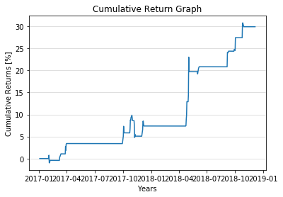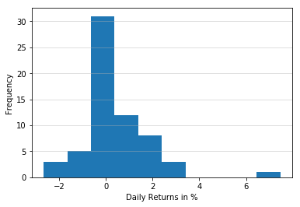

* Cumulative Return: 29.90%
* No. of Years = 1.9
* Distribution of Daily Returns
  + Average = 0.43% and Standard Deviation = 0.53%
  + Skewness = 6.6 and Kurtosis = 88.11
* Annualized Return: 14.59% and Sharpe Ratio = 0.8
* Maximum Drawdown of 4.62% with recovery period of 169 days

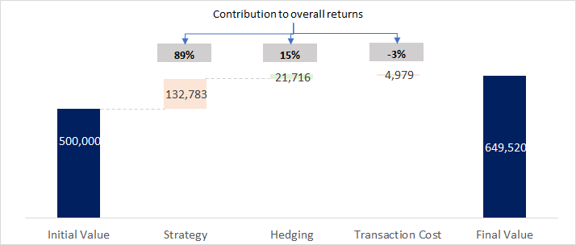

The results for the out-sample testing was similar to that of the in-sample period. ~90% of the returns were contributed by the basic strategy while the hedge contributed positively to the portfolio performance.

1. Trading Recommendation

This implementation proved rather favourable and although quite simple could be worth trading, although would like to have a bit larger sample set before conclusively trading to see if there is a bias in the data available. If the results are similar with larger data sets, a trade would be recommended.

V.  Appendix

All code.